NEURO INSTRUMENTS
Basic Bone Plating Instruments
Cross Drive Screw Driver Handle
Intended Use
The Cross Drive screw driver handle is the ergonomic grip component of the cross-drive screwdriver system used in neurosurgical cranial bone plating. It transmits controlled rotational torque to the corresponding shaft during insertion and removal of cross-drive mini screws that fix titanium mesh and cranial plates to the skull in cranioplasty and craniofacial reconstruction procedures. | 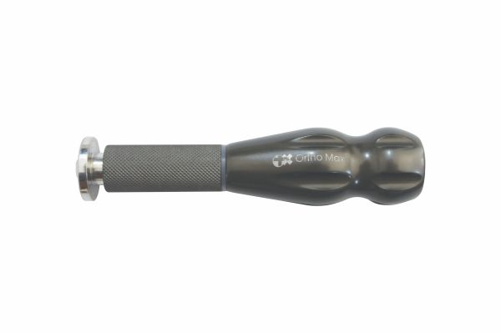
Function
The handle body accepts the detachable driver shaft through a precision quick-couple interface. The surgeon grips the knurled or textured handle and rotates it to drive the cross-drive screw into pre-tapped cranial bone. The ergonomic profile allows palm-grip or fingertip rotation, enabling both high-torque insertion in dense calvarium and fine-controlled final seating near critical neurovascular structures.
Advantages
Detachable Shaft System: The modular handle-and-shaft design allows the same handle to be used with different shaft lengths and tip sizes, reducing the instrument count on the cranial neurosurgical tray and enabling rapid tip changes when transitioning between different screw head sizes within one procedure.
Tactile Torque Feedback: The rigid handle construction transmits micro-vibrations from the screw-bone interface to the surgeon's palm, signalling full screw seating or impending thread strip-out — critical safety feedback when inserting mini screws into the variable-thickness calvarium of neurosurgical patients.
FAQ
Q: What screw types is this handle compatible with?
A: The handle is designed for the Cross Drive screw system used in titanium cranial mini-plate and mesh fixation; it is not cross-compatible with hex-socket or standard Phillips head neurosurgical screws without the appropriate matched shaft.
Q: How is over-tightening prevented during cranial screw insertion?
A: Tactile feedback through the handle signals the resistance change at full seating; a torque-limiting adaptor set to 0.1–0.2 Nm is recommended for thin calvarium regions where manual torque sensing alone is insufficient to prevent thread stripping.

NEURO INSTRUMENTS
Basic Bone Plating Instruments
Cross Drive Screw Driver Shaft
Intended Use
The Cross Drive screwdriver shaft is the working insert of the cross-drive screwdriver system, carrying the tip that engages the cross-drive screw head recess during cranial bone plating in neurosurgery. It connects to the driver handle and transmits rotational torque to mini screws used in titanium mesh and cranial plate fixation. | 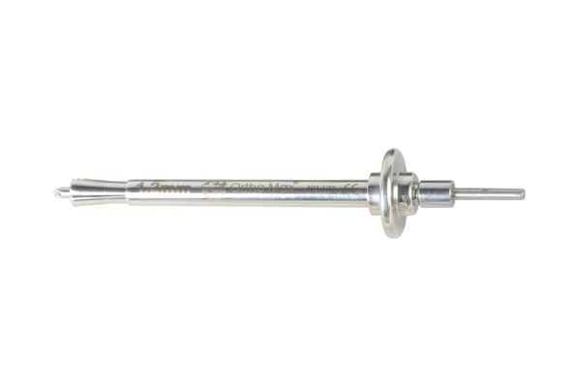
Function
The precision-machined cross-drive tip engages the matching cross recess in the screw head with full four-point contact. When the handle is rotated, the shaft transmits torque directly into the screw without cam-out, even when the driver angle is slightly off-axis — an important advantage in the deep operative fields of posterior fossa and temporal bone cranial approaches.
Advantages
Anti-Cam-Out Cross Tip: The four-point cross contact between driver tip and screw head distributes torque evenly, dramatically reducing the cam-out forces that strip the screw head during final seating — a significant advantage over two-point Phillips tips in the confined depths of cranial surgical corridors.
Interchangeable Length Options: Shafts are available in short, medium, and long lengths to match different operative field depths, from superficial temporal plating to deep posterior fossa approaches, without requiring a completely different driver instrument for each depth.
FAQ
Q: How is the shaft attached to the handle?
A: The shaft's proximal end connects to the handle via a precision quick-couple mechanism — insert and rotate a quarter-turn to lock; reverse to release. The connection is rigid under torque to prevent shaft spin within the handle during screw insertion.
Q: What length shaft is used for posterior fossa plating?
A: Extended shafts of 150–200 mm are used for posterior fossa and skull base approaches where the screw location is deep and the handle must remain outside the wound margins to provide adequate rotation clearance.

NEURO INSTRUMENTS
Basic Bone Plating Instruments
Idrill Screwdriver
Intended Use
The Idrill screwdriver is a precision torque instrument designed for inserting self-drilling neurosurgical mini screws used in cranial titanium mesh and bone plate fixation. The self-drilling screw design eliminates the need for a separate pilot drill, simplifying the cranial plating workflow and reducing the number of steps in cranioplasty and skull base reconstruction. | 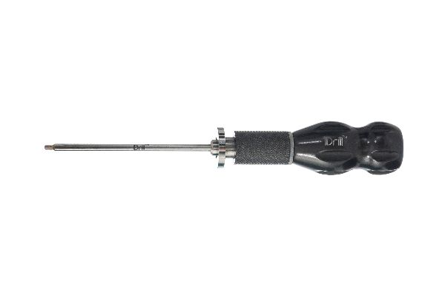
Function
The driver tip matches the Idrill screw head geometry and engages securely to transmit rotation. The surgeon applies downward axial pressure while rotating, allowing the screw's self-drilling tip to penetrate the calvarium without a pre-drilled hole. The tip design maintains full engagement even under the combined axial and rotational forces generated during self-drilling insertion through cranial cortex.
Advantages
Eliminates Separate Drilling Step: Self-drilling Idrill screws inserted with this driver require no pre-drilled pilot hole, removing one step from the cranial plating sequence, reducing operative time and eliminating the risk of pilot hole mislocation that misaligns the screw relative to the plate or mesh hole.
One-Step Secure Fixation: The driver-screw system achieves cortical penetration and thread engagement in a single continuous rotation, simplifying the operative workflow in cranioplasty cases where multiple mesh fixation points require rapid sequential screw placement across a large cranial defect.
FAQ
Q: Can the Idrill driver be used with standard (non-self-drilling) cranial screws?
A: No — the driver tip geometry is matched to the Idrill screw head profile; using it with standard screws risks stripping the screw head or driver tip. Use the standard cross-drive shaft for non-self-drilling implants.
Q: Is a separate depth stop needed with self-drilling screws?
A: Yes — a depth-limiting sleeve or torque-limiting attachment is recommended to prevent the self-drilling screw from advancing beyond the calvarium inner table and penetrating the dura, especially in thin-bone regions of the temporal and posterior fossa.

NEURO INSTRUMENTS
Basic Bone Plating Instruments
Mesh Bender
Intended Use
The mesh bender is a contouring instrument used in neurosurgical cranioplasty to shape titanium cranial mesh to the precise three-dimensional curvature of the patient's skull defect. Accurate mesh contouring is essential for restoring normal cranial contour, preventing mesh palpability, and achieving the close bone-to-mesh contact that promotes tissue ingrowth through the mesh perforations. | 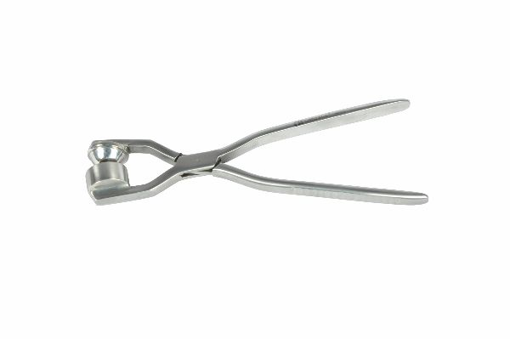
Function
The instrument's jaws or rollers engage the titanium mesh at defined points and apply controlled bending force when the handles are closed. Sequential repositioning of the mesh bender across the mesh surface allows progressive three-dimensional shaping to match the complex curvature of the calvarium, including compound curves at the temporal, frontal, and parietal regions.
Advantages
Precise Cranial Curvature Matching: The mesh bender allows millimetre-level adjustment of mesh contour to match individual patient cranial curvature, preventing the visible step-offs and palpable ridges that poorly contoured mesh creates under thin scalp in cosmetically sensitive frontal and temporal cranioplasty sites.
Preserves Mesh Integrity: The instrument's jaw design distributes bending force across multiple mesh strands simultaneously, preventing the stress concentration at individual mesh junctions that localised plier bending causes — maintaining mesh mechanical strength and corrosion resistance at bent areas.
FAQ
Q: Can pre-formed titanium mesh be further adjusted intraoperatively with the bender?
A: Yes — even computer-planned, pre-formed titanium mesh requires minor intraoperative adjustment to account for positioning changes from planning CT to operative position; the mesh bender provides these fine corrections without risking mesh damage.
Q: How many times can titanium mesh be bent before it fatigues?
A: Titanium work-hardens with each bend; limit adjustments to 2–3 bend-and-straighten cycles at any one point; excessive re-bending creates fatigue cracking at mesh strand junctions that weakens the long-term structural integrity of the implant.

NEURO INSTRUMENTS
Basic Bone Plating Instruments
Mesh Cutter
Intended Use
The mesh cutter is a precision cutting instrument used to trim titanium cranial mesh to the exact dimensions of the skull defect during cranioplasty and cranial reconstruction in neurosurgery. It cuts through titanium mesh strands cleanly without deforming the surrounding mesh geometry or leaving sharp edges that could injure the overlying scalp. | 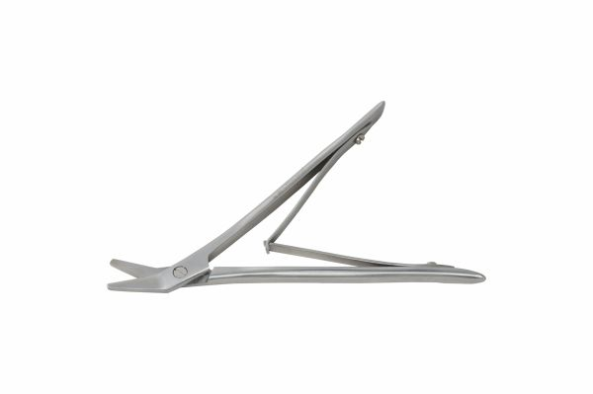
Function
Hardened cutting jaws are positioned over the mesh strand at the desired cut location. Closing the handles shears the titanium strand in a single clean cut. The jaw geometry prevents adjacent mesh strands from bending or distorting as each strand is cut, maintaining the planned mesh shape up to the trimmed margin.
Advantages
Sharp, Burr-Free Strand Cuts: The precision-ground cutting edges shear titanium mesh strands cleanly without creating metal burrs at the cut end — burrs on trimmed mesh edges can erode through the scalp over time, causing wound dehiscence and implant exposure that requires revision surgery.
Maintains Adjacent Mesh Geometry: The jaw design limits cutting force to the target strand without distorting the surrounding mesh, so the mesh retains its contoured shape right up to the trimmed margin — preventing the rim distortion that makes close cranial defect fitting difficult after trimming.
FAQ
Q: Should mesh edges be smoothed after cutting?
A: Yes — all cut mesh edges should be inspected and any sharp projecting strand ends smoothed with a fine bone file or folded back with the mesh bender before implantation to prevent scalp erosion from sharp titanium points against the galea.
Q: What mesh thickness can this cutter handle?
A: Standard cranial titanium mesh cutters handle mesh strand diameters up to 0.8 mm; thicker structural mesh or thick-bar cranial plates require heavy-duty plate cutters rather than the fine mesh-specific instrument.

NEURO INSTRUMENTS
Basic Bone Plating Instruments
Mini Plate Cutter (Vertical)
Intended Use
The mini plate cutter vertical model is used in neurosurgical bone plating to trim titanium mini cranial plates to the correct length for the specific craniofacial or skull base reconstruction site. It cuts through plate holes between screws, shortening the plate without deforming adjacent hole geometry, to achieve the exact fit required in neurosurgical mini-plate fixation. | 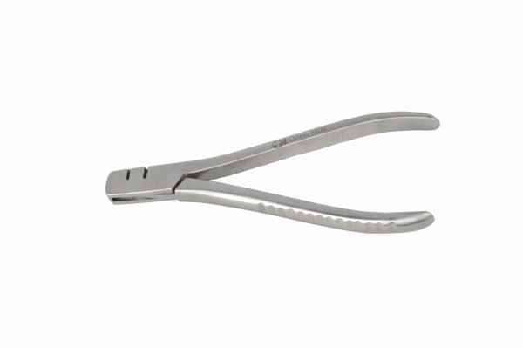
Function
The cutter jaws position between two adjacent plate holes at the intended cut point. Closing the handles drives hardened blades through the plate cross-section in a single perpendicular shear. The vertical cutting orientation produces a flat plate end without the metal curl or angular deformation that offset-jaw cutters create at the cut surface.
Advantages
Perpendicular End Geometry: Vertical blade alignment shears the plate end squarely, producing a flat cut face that does not create stress risers or sharp points against the periosteum — a critical detail in neurosurgical plating where thin scalp and periosteum are at risk of pressure erosion from irregular implant end profiles.
Screw Hole Preservation: Cutting precisely between plate holes maintains the full geometry of the adjacent hole, ensuring the last plate hole remains usable for a screw after trimming — essential for achieving the minimum screw count needed for stable cranial fixation on short plate constructs.
FAQ
Q: Can neurosurgical cranial plates be trimmed intraoperatively?
A: Yes — trimming is routinely performed intraoperatively to match the plate to each patient's anatomy; always trim before bending to the final contour, as cutting a pre-contoured plate may alter the bend geometry at the cut end.
Q: Is filing necessary after cutting with the vertical cutter?
A: The perpendicular cut produces minimal burring; a brief smoothing with a fine bone file confirms no sharp projections before plate implantation under thin pericranium and scalp.

NEURO INSTRUMENTS
Basic Bone Plating Instruments
Modelling Lever
Intended Use
The modelling lever in the neurosurgical bone plating set is used to make fine, precise contour adjustments to titanium mini cranial plates directly on the operative field. It allows the surgeon to match the plate exactly to the cranial surface curvature before final screw fixation, ensuring intimate plate-to-bone contact across the entire plate length. | 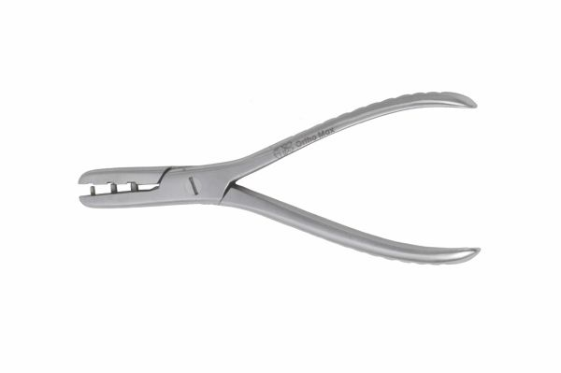
Function
The lever's notched or slotted working end engages a plate hole margin or the plate edge. Controlled bending force applied through the ergonomic handle creates a small angular deflection in the plate at the point of engagement, allowing progressive, incremental contouring corrections without removing the plate from the operative field for re-bending on a separate bender.
Advantages
In-Situ Plate Contouring: The modelling lever allows fine contour corrections while the plate is trialled against the skull, dramatically reducing the cycle of plate removal, bench bending, and re-trialling that consumes operative time and extends anaesthesia in cranioplasty and cranial fracture repair procedures.
Fatigue-Controlled Bending: Incremental small-angle corrections through the lever avoid the repeated sharp bending that accelerates titanium fatigue; each lever correction produces a smooth, distributed deformation that preserves the plate's long-term mechanical performance under the cyclic loads of jaw and head musculature.
FAQ
Q: How many bending cycles are safe for a titanium cranial plate?
A: Titanium mini cranial plates tolerate 2–4 bending cycles before fatigue endurance is significantly reduced; always aim for the correct contour in the fewest bends possible, and discard any plate showing visible surface cracks at bent regions.
Q: Can the modelling lever be used on titanium mesh as well as plates?
A: The lever is optimised for solid mini plate edges and holes; for mesh adjustment the dedicated mesh bender is preferred, as the lever's point force risks pulling individual mesh strands out of the junction welds.

NEURO INSTRUMENTS
Basic Bone Plating Instruments
Plier
Intended Use
The neurosurgical plier is a multi-purpose gripping and bending instrument used in cranial bone plating procedures to grip mini plates, handle mesh components, bend wire, and manipulate small implant components on the sterile field. It provides secure, controlled grip without the surface marking that serrated-jaw instruments cause on smooth titanium plate surfaces. | 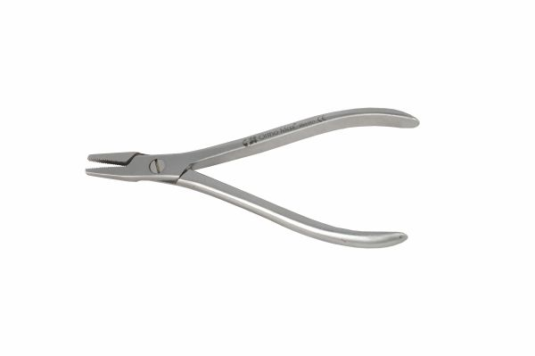
Function
Smooth or lightly textured jaw faces provide secure grip on flat plate surfaces and round wire without scoring or contaminating the titanium's oxide passivation layer. A box-joint hinge delivers consistent grip force with minimal jaw opening, enabling single-handed manipulation of small cranial implant components during the rapid sequencing of neurosurgical bone plating.
Advantages
Surface-Preserving Grip: Smooth jaw faces grip titanium mini plates and mesh without gouging or scratching the anodised titanium surface — surface damage on cranial implants creates crevices that concentrate corrosion under the thin pericranium, compromising long-term implant integrity and biocompatibility.
Universal Implant Handling: A single plier handles mini plates, mesh trimming scrap, wire, and small screws during cranial plating, reducing the number of instruments the scrub nurse must manage on the complex neurosurgical tray and maintaining sterile technique through reduced instrument exchange frequency.
FAQ
Q: Can the neurosurgical plier be used to bend mini cranial plates?
A: For minor localised bends the plier can be used, but the modelling lever provides better control and less risk of plate surface marking; use the plier for gripping and holding tasks, the modelling lever for intentional contouring corrections.
Q: What jaw width is appropriate for cranial mini plate work?
A: Jaw widths of 4–6 mm are ideal for the 1.0–1.5 mm thick mini plates used in neurosurgical cranial fixation; wider jaws provide more stability while still fitting between the closely spaced holes of narrow cranial plates.

NEURO INSTRUMENTS
Basic Bone Plating Instruments
Screw-Plate Holding Forceps
Intended Use
Screw-plate holding forceps are precision gripping instruments used to position and hold neurosurgical titanium mini cranial plates and individual mini screws on the sterile field without direct finger contact. They maintain strict aseptic technique during implant transfer and plate positioning before screw fixation in cranioplasty and skull base reconstruction procedures. | 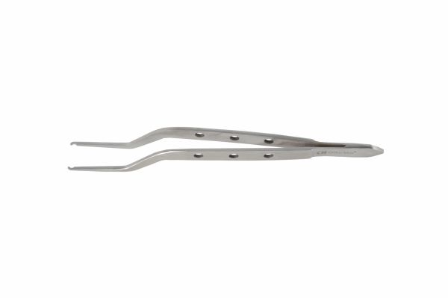
Function
Delicate, narrow jaws clamp the plate edge or screw shank through spring-loaded or ratchet tension. The forceps allow the scrub nurse to pass mini plates and screws to the surgeon without glove-to-implant contact, and allow the surgeon to position a plate accurately over the skull before inserting the first fixation screw.
Advantages
No-Touch Implant Transfer: Forceps transfer of mini cranial plates and screws eliminates bare-hand contact with implant surfaces, preserving the titanium oxide passivation layer and preventing protein contamination that can reduce titanium's long-term tissue compatibility under the thin biological environment of the neurosurgical scalp flap.
Precise Plate Placement: The forceps allow millimetre-accurate plate positioning across the cranial defect margin before the first screw is inserted, ensuring the plate bridges the defect correctly and the screw holes align with suitable bone on both sides of the repair site.
FAQ
Q: Can the same forceps be used for both plates and screws?
A: Yes — the jaw tip width handles both tasks; narrow-nose tips grip screw shanks for no-touch transfer to the driver, while the same jaws open wider to clamp the plate edge for positioning over the skull defect.
Q: What is the risk of dropping implants without holding forceps?
A: Dropped sterile implants must be discarded and replaced — titanium cranial mini plates are expensive specialty implants; the cost of a single dropped plate far exceeds the cost of a dedicated pair of holding forceps, justifying their routine use in every neurosurgical bone plating case.

